Straight–Wavy Open Shapes
# Source: AI Source: Provided by: [Data Path: Persons Table -> ID Column: 1, Name_En Column: Motasem Essam] -> From: [ChatGPT] on [7/25/2026]
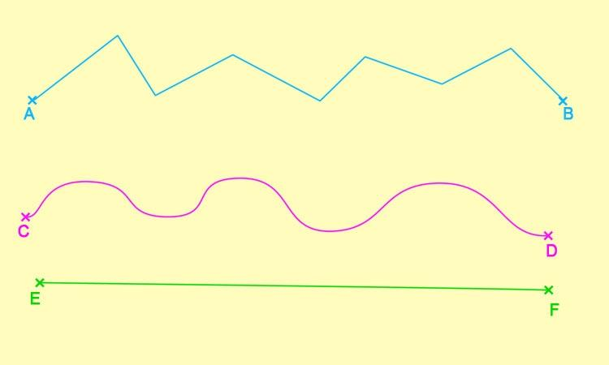
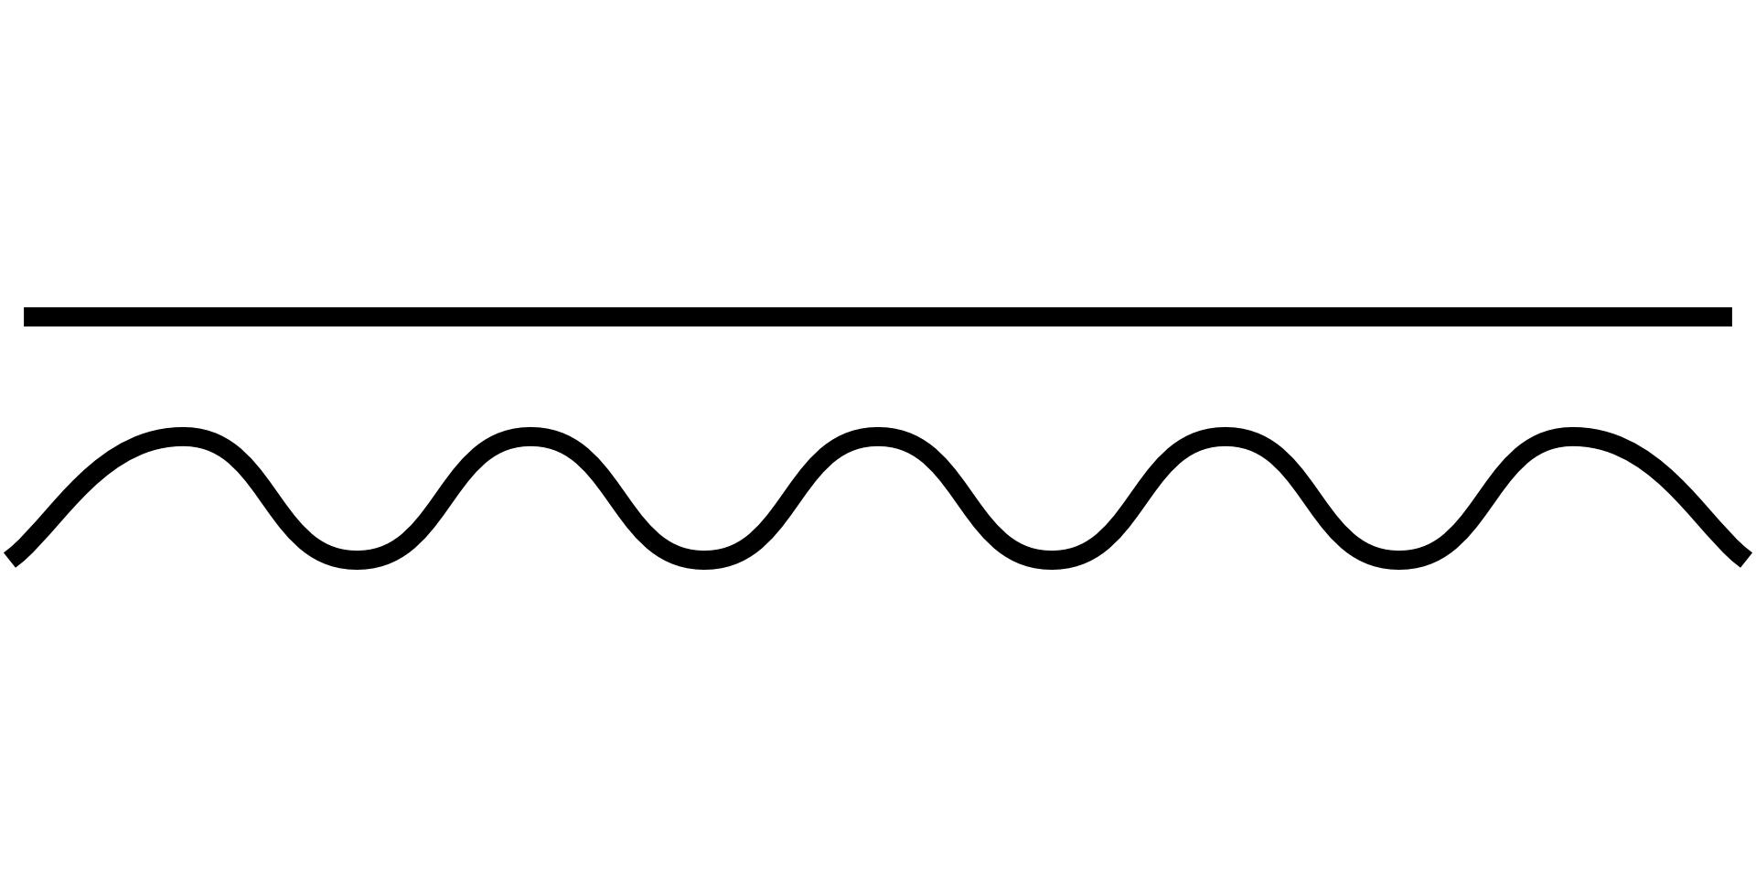
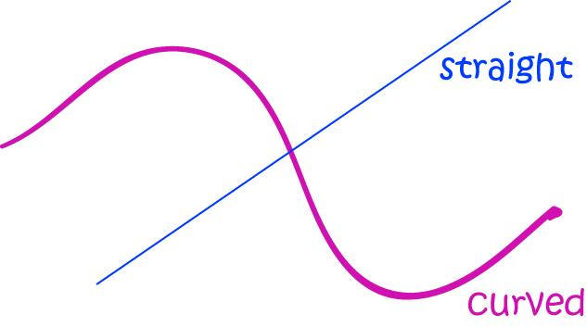

Definition
# Source: AI Source: Provided by: [Data Path: Persons Table -> ID Column: 1, Name_En Column: Motasem Essam] -> From: [ChatGPT] on [7/25/2026]
A Straight–Wavy Open Shape is an open mixed shape that combines one or more straight-line segments with one or more wavy curved portions.
$$\boxed{\text{Straight–Wavy Open Shape}=\text{Straight Segment(s)}+\text{Wavy Curve(s)}+\text{Open Boundary}}$$
The shape is open because the path does not completely return to its starting point.

Characteristics
# Source: AI Source: Provided by: [Data Path: Persons Table -> ID Column: 1, Name_En Column: Motasem Essam] -> From: [ChatGPT] on [7/25/2026]
A Straight–Wavy Open Shape:
- Is open.
- Contains at least one straight segment.
- Contains at least one wavy curved portion.
- Combines linear and curved geometry.
- Has two or more endpoints.
- May have regular or irregular waves.
- May have smooth or cornered transitions.
- Does not enclose an area by itself.
- Can be symmetric or asymmetric.
- Can be simple or complex.

Types of Straight–Wavy Open Shapes

1. Single-Straight–Wavy Open Shape
# Source: AI Source: Provided by: [Data Path: Persons Table -> ID Column: 1, Name_En Column: Motasem Essam] -> From: [ChatGPT] on [7/25/2026]
A simple open shape containing one straight segment and one wavy curved portion.
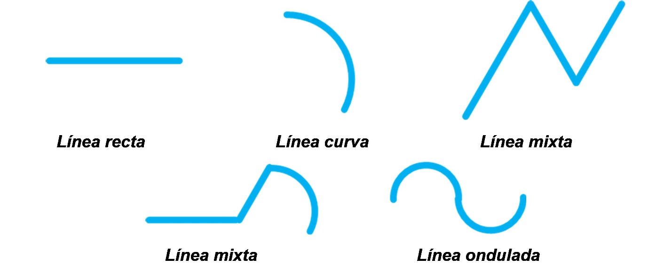

2. Multi-Straight–Wavy Open Shape
# Source: AI Source: Provided by: [Data Path: Persons Table -> ID Column: 1, Name_En Column: Motasem Essam] -> From: [ChatGPT] on [7/25/2026]
An open path containing several straight segments connected to one or more wavy curves.
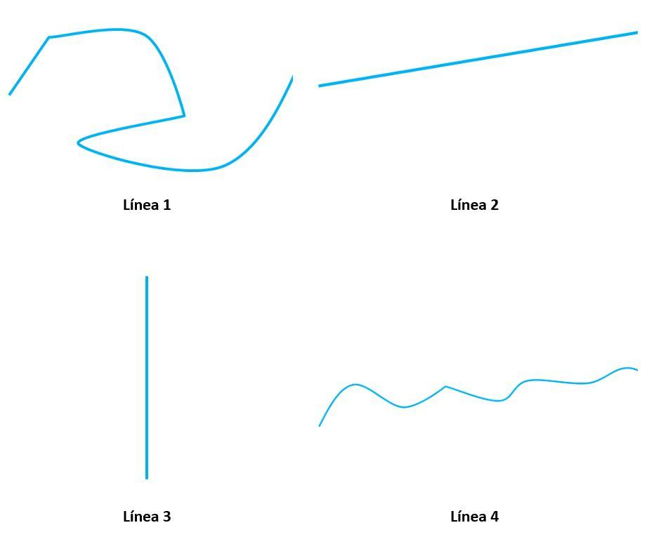
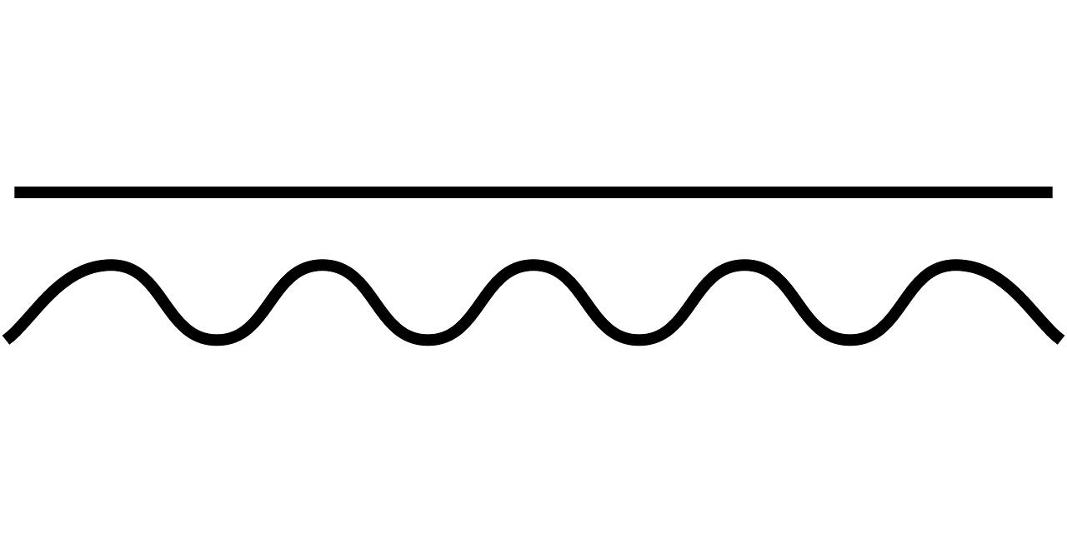

3. Smooth Straight–Wavy Open Shape
# Source: AI Source: Provided by: [Data Path: Persons Table -> ID Column: 1, Name_En Column: Motasem Essam] -> From: [ChatGPT] on [7/25/2026]
The straight and wavy portions connect with smooth transitions.
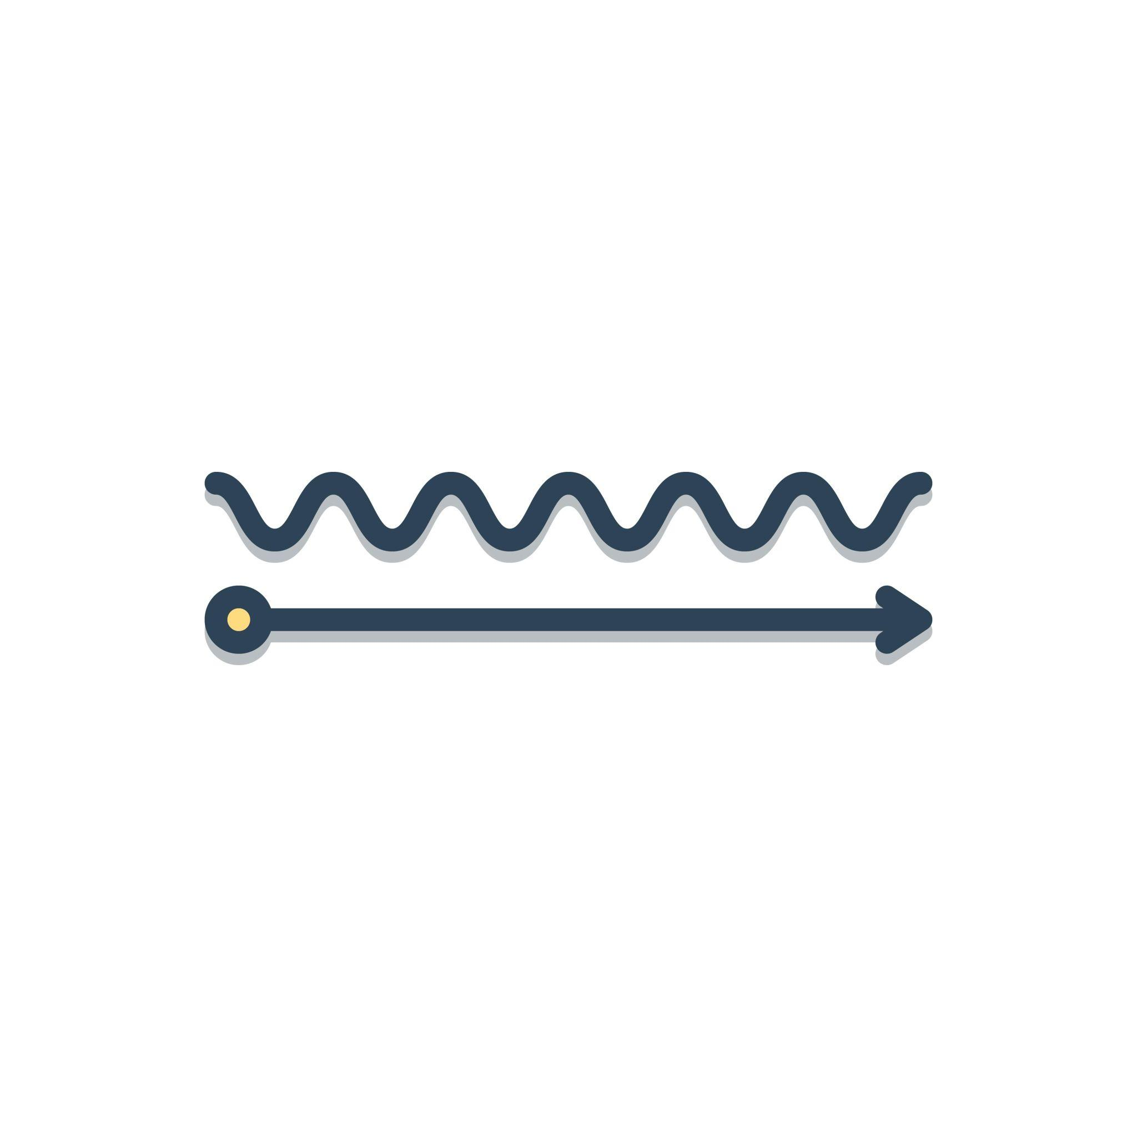
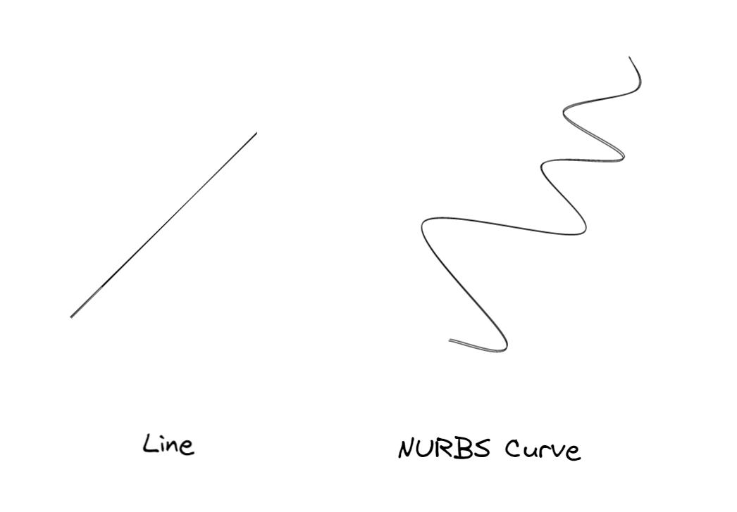

4. Cornered Straight–Wavy Open Shape
# Source: AI Source: Provided by: [Data Path: Persons Table -> ID Column: 1, Name_En Column: Motasem Essam] -> From: [ChatGPT] on [7/25/2026]
A straight segment meets a wavy portion with a visible change in direction.
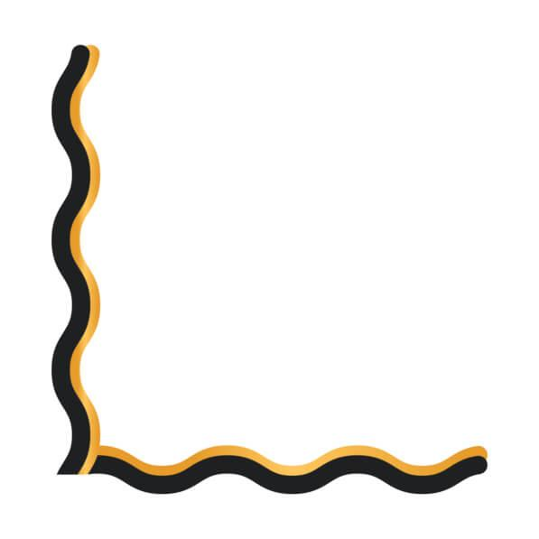
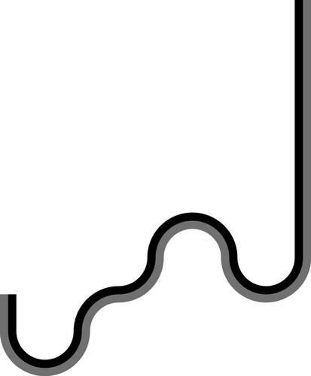

5. Symmetric Straight–Wavy Open Shape
# Source: AI Source: Provided by: [Data Path: Persons Table -> ID Column: 1, Name_En Column: Motasem Essam] -> From: [ChatGPT] on [7/25/2026]
The straight and wavy portions are arranged with recognizable symmetry.
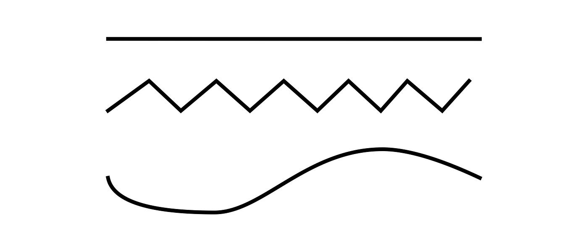

6. Asymmetric Straight–Wavy Open Shape
# Source: AI Source: Provided by: [Data Path: Persons Table -> ID Column: 1, Name_En Column: Motasem Essam] -> From: [ChatGPT] on [7/25/2026]
The straight and wavy portions have unequal lengths, positions, or wave patterns.
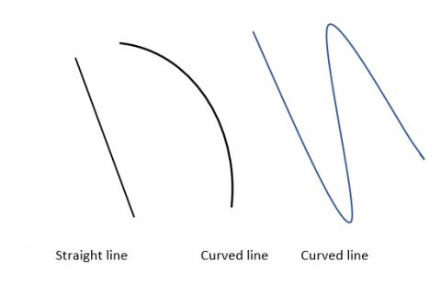

7. Regular-Wavy Straight Open Shape
# Source: AI Source: Provided by: [Data Path: Persons Table -> ID Column: 1, Name_En Column: Motasem Essam] -> From: [ChatGPT] on [7/25/2026]
The wavy portion contains approximately repeated waves with similar amplitude and spacing.
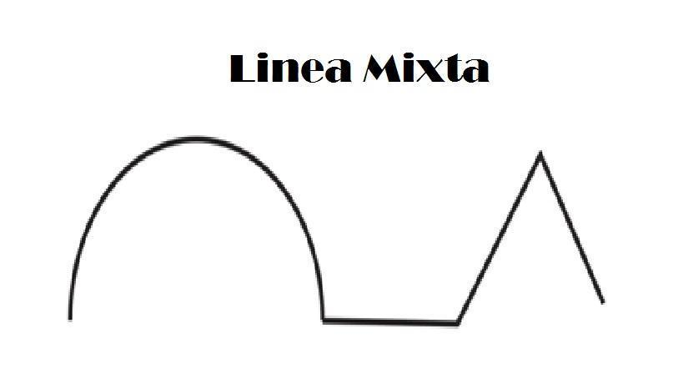

8. Irregular-Wavy Straight Open Shape
# Source: AI Source: Provided by: [Data Path: Persons Table -> ID Column: 1, Name_En Column: Motasem Essam] -> From: [ChatGPT] on [7/25/2026]
The wavy portion has changing amplitudes, spacing, or curvature.

9. Sinuous Straight–Wavy Open Shape
# Source: AI Source: Provided by: [Data Path: Persons Table -> ID Column: 1, Name_En Column: Motasem Essam] -> From: [ChatGPT] on [7/25/2026]
A long, smoothly winding wavy portion is combined with one or more straight sections.

10. Zigzag–Wavy Open Shape
# Source: AI Source: Provided by: [Data Path: Persons Table -> ID Column: 1, Name_En Column: Motasem Essam] -> From: [ChatGPT] on [7/25/2026]
Straight segments form a zigzag-like section while another portion contains waves.
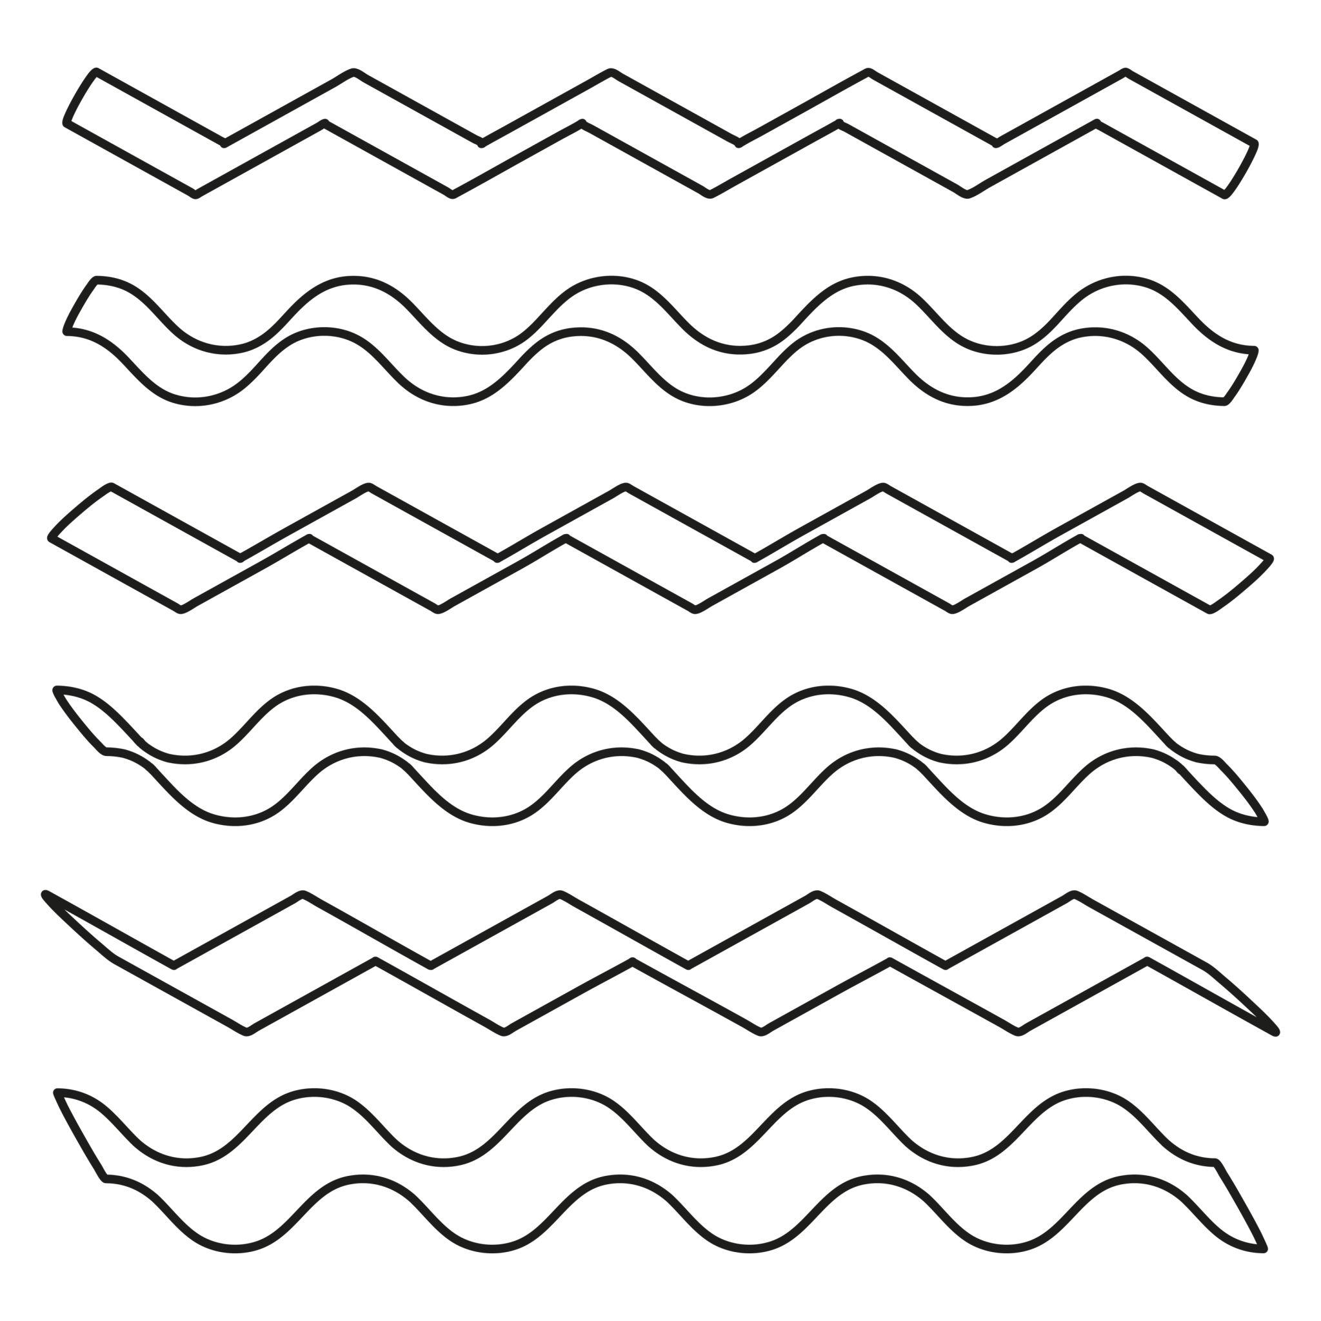
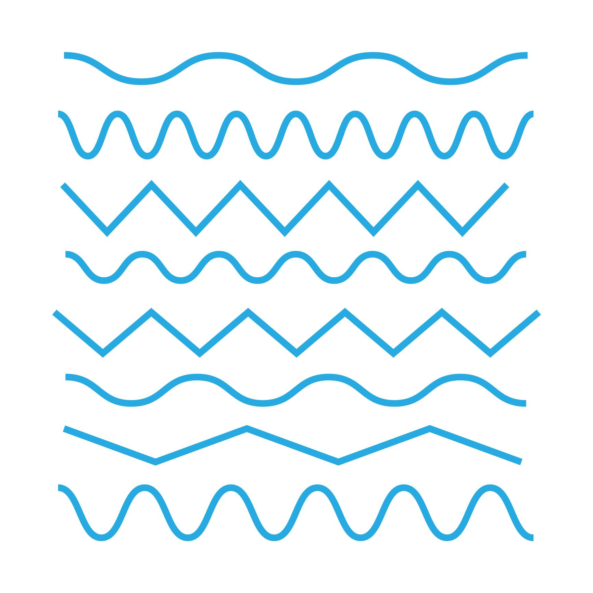

11. Freeform Straight–Wavy Open Shape
# Source: AI Source: Provided by: [Data Path: Persons Table -> ID Column: 1, Name_En Column: Motasem Essam] -> From: [ChatGPT] on [7/25/2026]
A freely designed combination of straight segments and wavy curves.
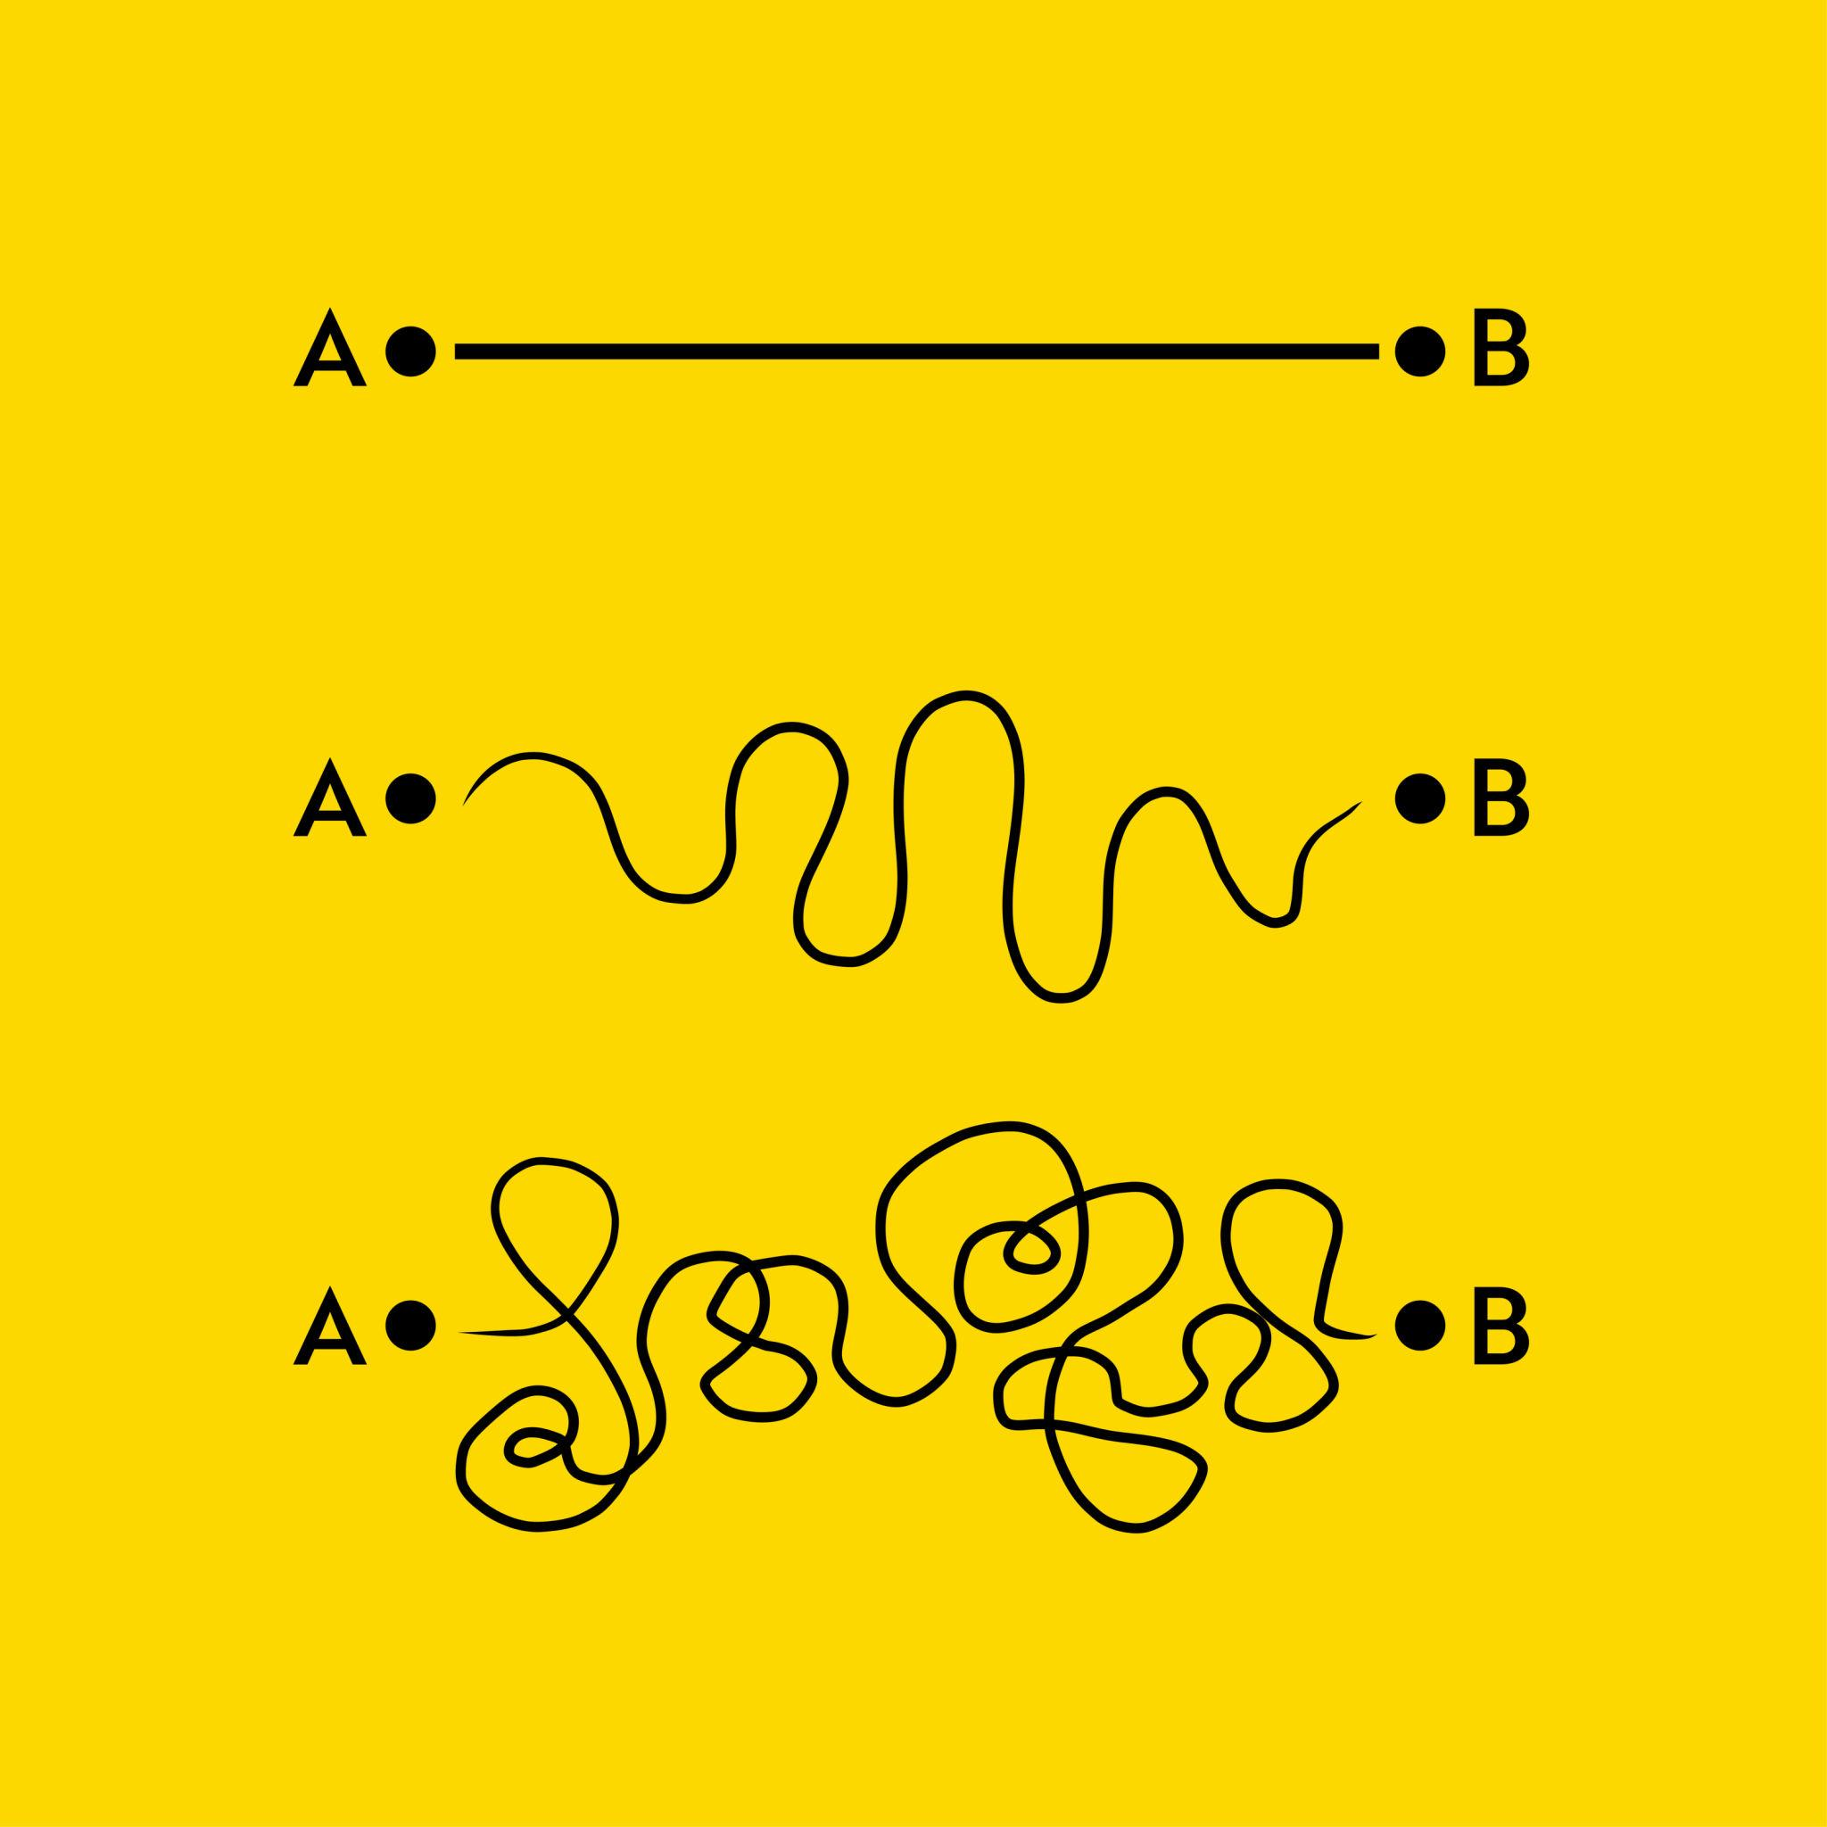
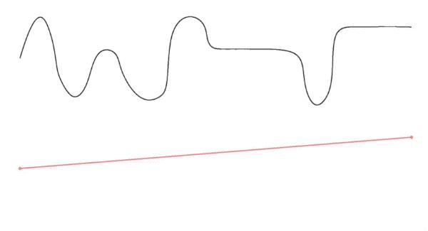

12. Complex Straight–Wavy Open Shape
# Source: AI Source: Provided by: [Data Path: Persons Table -> ID Column: 1, Name_En Column: Motasem Essam] -> From: [ChatGPT] on [7/25/2026]
A more complicated open path containing multiple straight segments and several wavy sections.
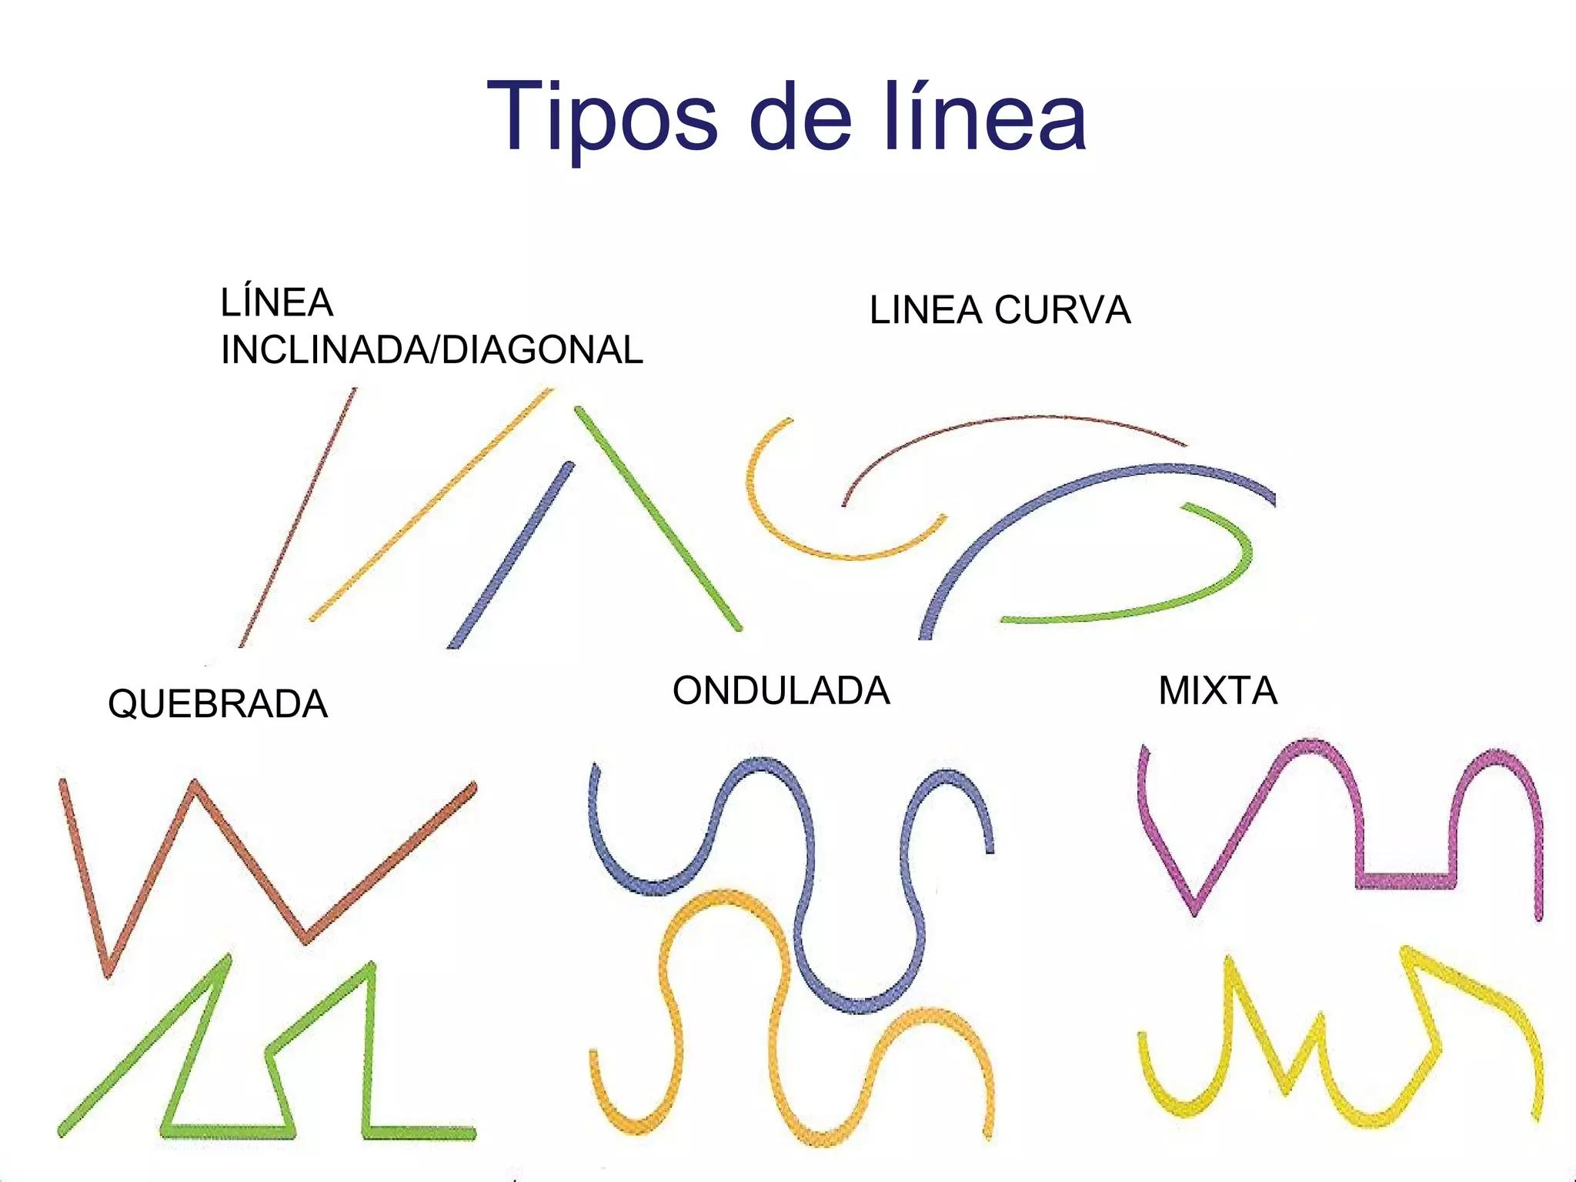

Straight–Wavy vs. Circular–Freeform Open Shapes
# Source: AI Source: Provided by: [Data Path: Persons Table -> ID Column: 1, Name_En Column: Motasem Essam] -> From: [ChatGPT] on [7/25/2026]
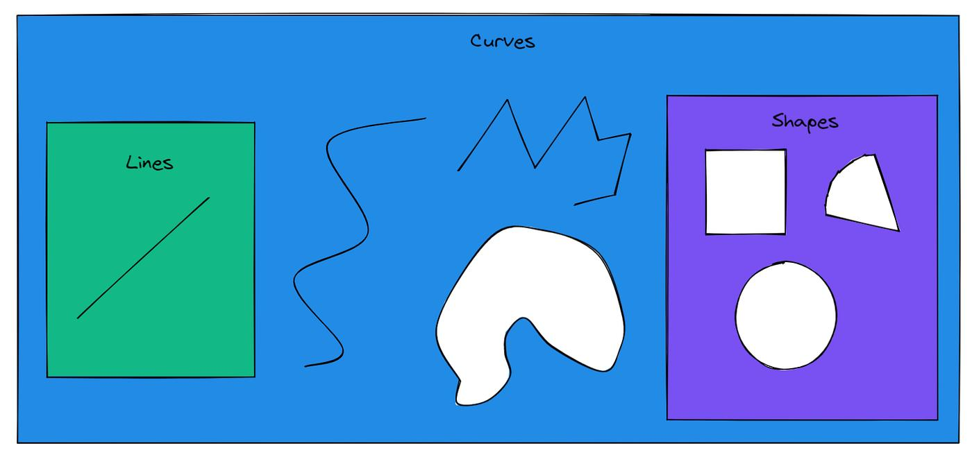
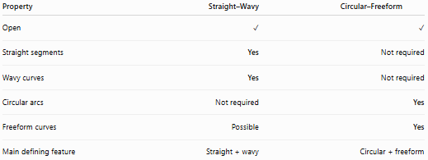
Property | Straight–Wavy | Circular–Freeform
Open | ✓ | ✓
Straight segments | Yes | Not required
Wavy curves | Yes | Not required
Circular arcs | Not required | Yes
Freeform curves | Possible | Yes
Main defining feature | Straight + wavy | Circular + freeform

Straight–Wavy vs. Polygon–Organic Open Shapes
# Source: AI Source: Provided by: [Data Path: Persons Table -> ID Column: 1, Name_En Column: Motasem Essam] -> From: [ChatGPT] on [7/25/2026]
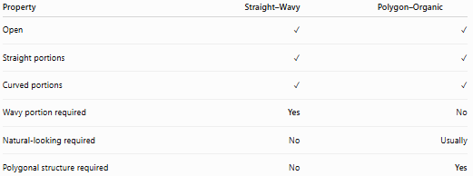
Property | Straight–Wavy | Polygon–Organic
Open | ✓ | ✓
Straight portions | ✓ | ✓
Curved portions | ✓ | ✓
Wavy portion required | Yes | No
Natural-looking required | No | Usually
Polygonal structure required | No | Yes

Key Points
# Source: AI Source: Provided by: [Data Path: Persons Table -> ID Column: 1, Name_En Column: Motasem Essam] -> From: [ChatGPT] on [7/25/2026]
A Straight–Wavy Open Shape is:
$$\boxed{\text{Open}+\text{Straight}+\text{Wavy}}$$
It:
- Contains at least one straight segment.
- Contains at least one wavy curve.
- Has two or more endpoints.
- Does not form a closed boundary.
- May have regular or irregular waves.
- May be smooth or cornered.
- Can be symmetric, asymmetric, freeform, or complex.

Conclusion
# Source: AI Source: Provided by: [Data Path: Persons Table -> ID Column: 1, Name_En Column: Motasem Essam] -> From: [ChatGPT] on [7/25/2026]
Straight–Wavy Open Shapes combine straight-line geometry with wavy curved geometry in an open path. The defining characteristic is the coexistence of at least one straight segment and at least one wavy portion, making this a distinct category of Open Mixed Shapes.

